Excalibur Crossbow String & Brace Height Guide

Crossbow | Length | Serving | Material | Part # | Brace
Axe/Mag 340, Mag Air | 26 1/8” | End – BCY 3D  Center - .036 Angel Majesty | BCY Force 10 | 1993 | 2.5” – 3”
Micro 308, 315, 355, Suppressor 355, New Micro 335, Assassin 360, Micro 360TD, Assassin 400TD, Suppressor 400, Micro 340TD, TwinStrike (x2), Twinstrike Tac2, Micro 380 | 26 1/8” | End – BCY 3D  Center - .036 Angel Majesty | BCY Force 10 | 1993 | 1.5”-2”
Micro 335 (original 3-degree riser) | 26 1/8” | End – BCY 3D  Center - .036 Angel Majesty | BCY Force 10 | 1993 | 1”-1.5”
Matrix Bulldog 400, Matrix Bulldog 380, Matrix Bulldog 330 | 31 1/8” | End – BCY 3D  Center - .036 Angel Majesty | BCY Force 10 | 1992 | 1.5”-2”
Grizzly, GRZ2, Cub, Bulldog 440, Assassin 420TD | 31 1/8” | End – BCY 3D  Center - .036 Angel Majesty | BCY Force 10 | 1992 | 1”-1.5”
Matrix Series  (405, 380, 355, 330, 310, Sapphire, G340) | 31 1/8” | End – BCY 3D  Center - .036 Angel Majesty | BCY Force 10 | 1992 | .5”-1”
Traditional Series – Mag-Tip Limbs  (Equinox, Exomax, Exomag Vortex,  Exocet, Vixen, Axiom, Ibex, Phoenix, Eclipse) | 35 1/2” | End – BCY 3D  Center - .036 Angel Majesty | BCY B55 Dacron  BCY Force 10 | 1994  1989 | .5”-1”
Traditional Series – Carved-Tip  Limbs (Exocet, Exomag, Exomax,  Vixen, Wolverine) | 35 1/2” | End – BCY 3D  Center - .036 Angel Majesty | BCY B55 Dacron | 2010 | .5”-1”
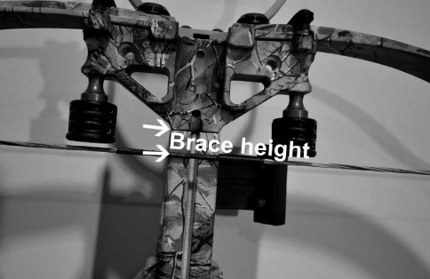
Note: Brace height is measured from the joint where the riser meets the rail. The string should never touch the suppressor pads. If it does, adjustments can be made by simply twisting the string counter clockwise until the correct brace height is achieved. You can’t over-twist the string. If the brace height is slightly more than stated it is still OK to use and will stretch with use.

